***17th ANNUAL SEAFORD WELLNESS***

***HOT CHOCOLATE 5K RUN/WALK***

**Proceeds Benefit Seaford Community Youth, Education, Environmental and Beautification Programs**

**9:00AM - Saturday, December 4, 2021**

**Start & Finish: at the Seaford High School**

**Hot Chocolate & Bagels for all participants!**

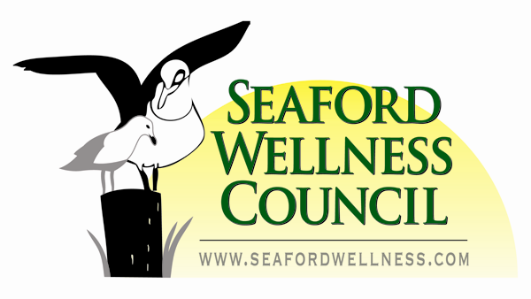

**ENTRY FEES for all participants: (No Refunds)**

**ALL ONLINE Registrations at** [**http://www.prtiming.com/**](http://www.prtiming.com/) **$25.00 + 2.50 fee. Closes 11:00pm 12/02/2021**

**ALL PAPER Applications received before Dec. 02, 2021 $30.00 - Afterwards $35.00 including Race Day**

**Baby Strollers, Bicycles, Skateboards and Pets Prohibited**

**Race # & T-shirt pick-up, and Late Registration $35.00:**

**Friday 12/03/2021: 5:30PM-8:00PM Saturday 12/04/2021: 7:30AM - 8:45AM**

**Seaford High School Auditorium, 1575 Seamans Neck Road, Seaford, NY 11783**

**Return this application with entry fee or REGISTER ONLINE at:** [**http://www.prtiming.com/**](http://www.prtiming.com/)

**RACE RESULTS BY: PR Timing (www.prtiming.com)**

**Awards: Overall Male & Female and Overall Male & Female Masters**

**Overall Male & Female Seaford Resident (courtesy Seaford Lions Club)**

**Medals: Age Groups: Top 3 Male & Female for 9 and under, then 5 year age groups to 90+**

**1st place centipede (minimum 5 runners per centipede) All centipede runners must be registered.**

**Course: Start Seamans Neck Rd. South of Seaford High School, North to Jerusalem Ave., East to Washington Ave., South to Brooklyn Ave., West to Seamans Neck Rd., North to the Finish at Seaford High School.**

**For more information visit** [**http://www.seafordwellness.com/HotChocolateRun.html**](http://www.seafordwellness.com/HotChocolateRun.html%20) **or contact:**

**Michael Di Silvio** [**mjdisilvio@yahoo.com**](mailto:mjdisilvio@yahoo.com) **at: 516-384-8536**



**Entry fee made payable to: Seaford Wellness Council, 3940 Sunset Avenue, Seaford, NY 11783**

**Name: ______________________________________________________________________________**

**Male ____ Female ____ Age on race day: _____ Date of Birth: ___________**

**Address: ____________________________________________________________________________**

**Town, State, Zip: ____________________________________________________________________**

**Phone: _____________________________________E-mail: __________________________________**

**X________________________________________________________ Date: _________________ Signature (Signature of parent or guardian if under 18 years of age)** In signing this form for myself (or participant below if he/ she is under 18), I understand and agree to absolve Seaford UFSD and The Seaford Wellness Council, and all sponsors, be they individuals or organizations, singly or collectively, of all blame for any injury, misadventure, harm, loss or inconvenience suffered in any of the activities associated with the said event. I attest and verify that I am physically fit and have sufficiently trained for the completion of this event, and that my physical condition has been verified by a licensed Medical Doctor. “The distribution of this flyer by the Seaford School District is a courtesy extended to the activities of this organization. In no way does the Seaford School District sponsor or accept any responsibility for these activities.”